**Assignment No. 12**

**Deploy and run project in aws without using port**

**Select all security groups except the default and go to Actions dropdown menu and choose “Delete security groups”**

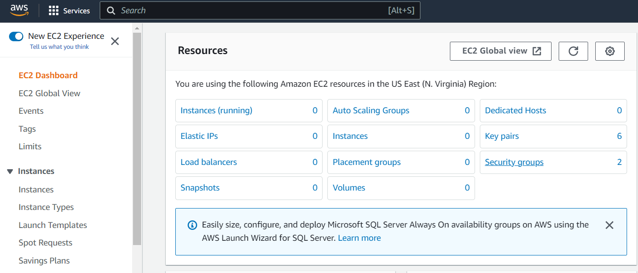

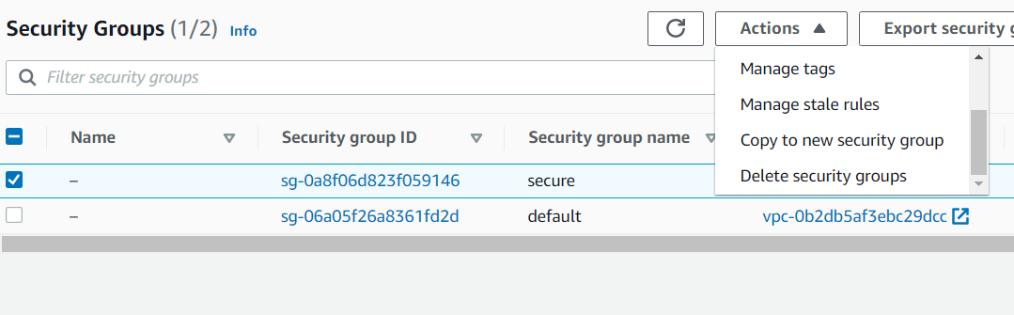

**Visit** **aws.amazon.com** **and Sign in.Go to EC2 Service and click on “Security Groups”**

**1.….**.

**2.**

**Add the Inbound rules with details as shown in the figure.After entering the details click on “Create security group”**

**Click on “Create security group”.Enter the “Security group name” and “Description”**

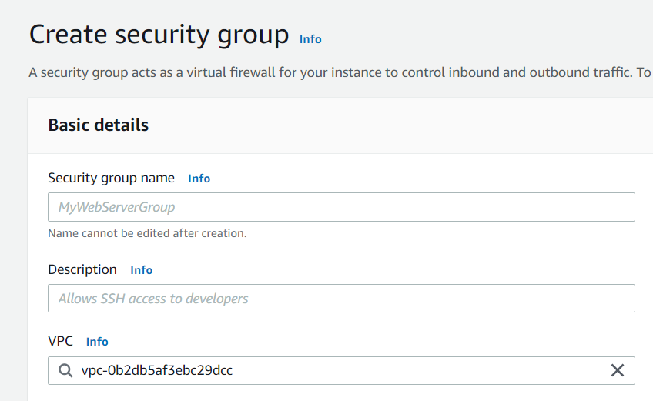

**s**

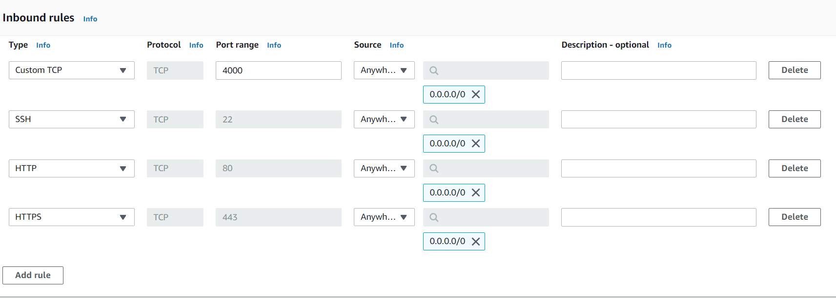

**3.**

**4.….**.

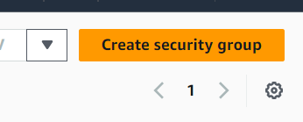

**Enter the instance name and select Ubuntu as Amazon Machine Image**

**6.**

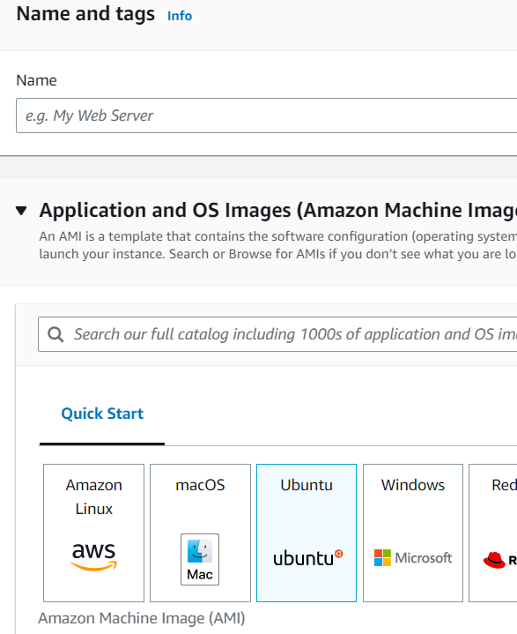

**Go to EC2 dashboard and Click on “Launch Instance”**

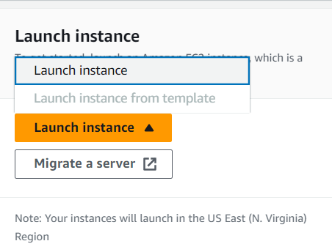

**5.**

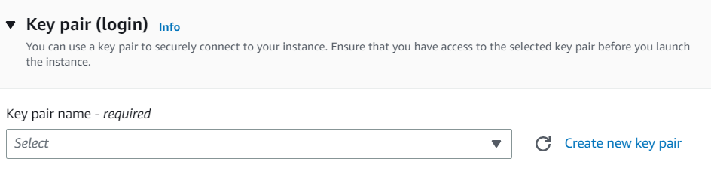

**Select key pair**

**7.**

**Under network settings ,click on “Select existing security group” and in the security group dropdown select the security group which you just created**

**8.**

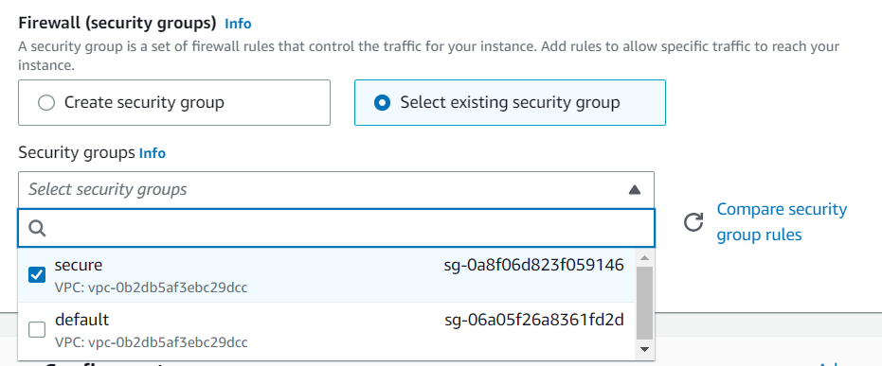

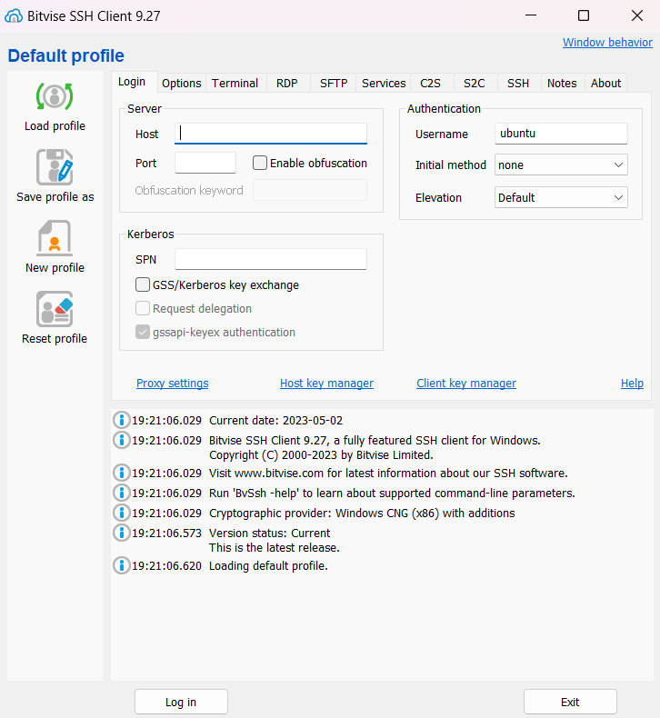

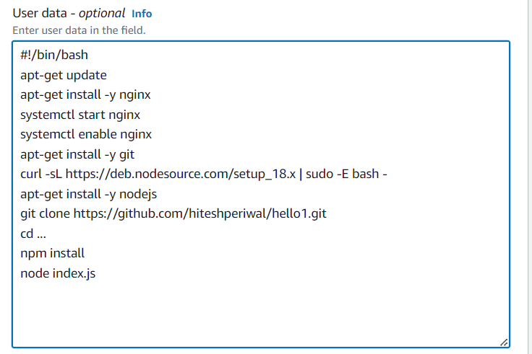

**Login to Bitwise SSH client using the public ip address.**

**10.**

**Type the following user data under advanced details section.Then click on create instance.**

**9.**

**After exiting the nano editor,type the following command in the terminal to restart the nginx web server.After restarting the nginx web server you will be able to access the website without the port number.Hence we are running project in aws without using port number.**

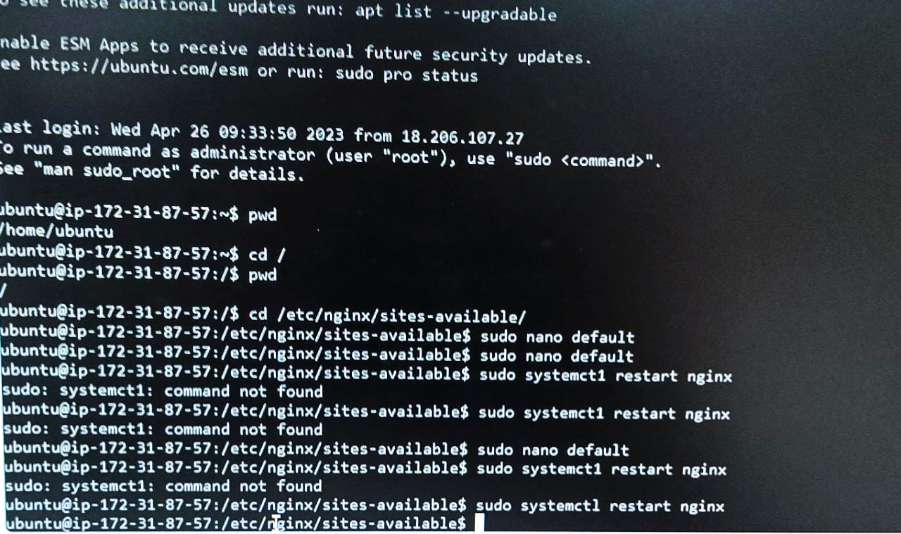

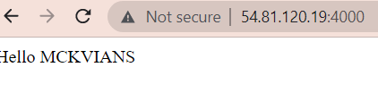

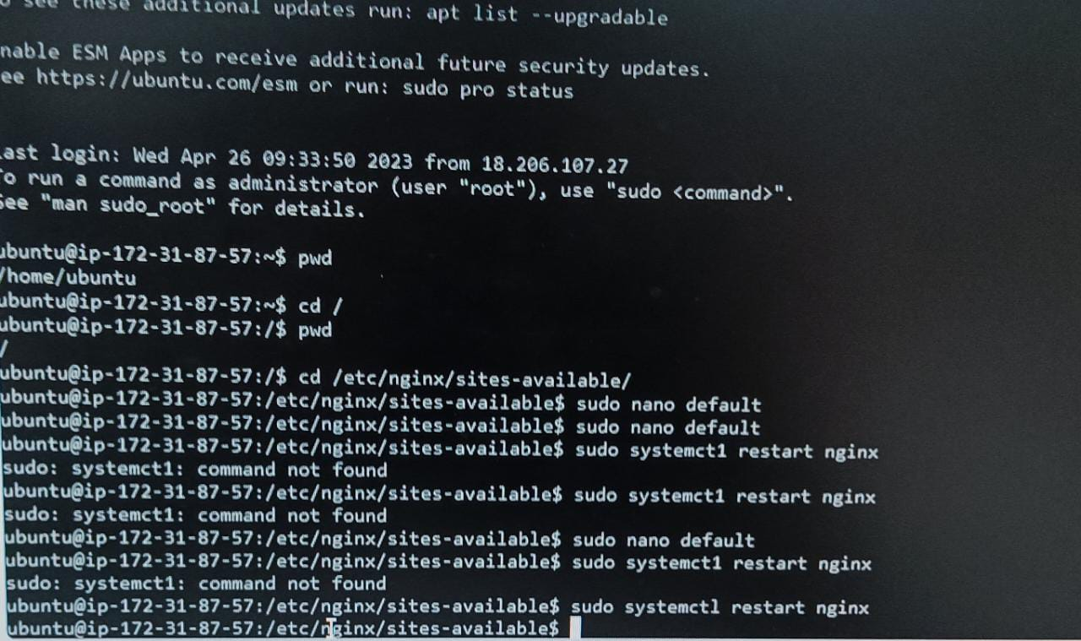

**Now login in Bitwise SSH client using the public ip address.Open the terminal and type the following commands and then open nano editor.In the nano editor after commenting the previous location type the new location as given below and then save and exit.**

**11.**

**12.….**.

